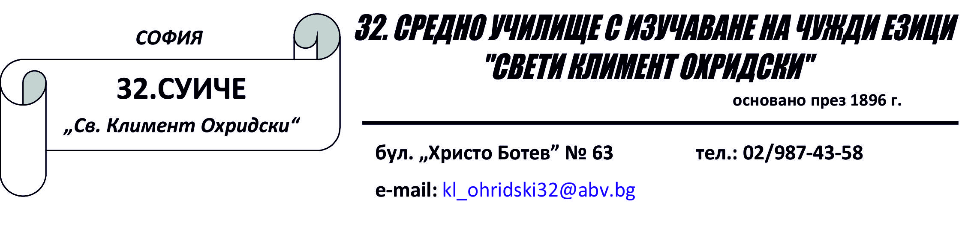

ПРОТОКОЛ
Вх. №....................../...................2016г.
от среща с ученик, психолог/ педагогически съветник и заместник -директор

Срещата е по повод мярка по чл. 114 от ПУДУ …………………………………………………
…………………………………………………………………………………………………………………………………………………………………………………………………………..
дата............................. час ...................................
На срещата присъстваха следните лица:
Ученик.........................................................................................................................................
Класен ръководител ................................................................................................................
Психолог/Пед.съветник ...........................................................................................................
Зам.-директор ...........................................................................................................................

В резултат на проведения разговор:
.....................................................................................................................................................
.....................................................................................................................................................
.....................................................................................................................................................
.....................................................................................................................................................
.....................................................................................................................................................
.....................................................................................................................................................

Кл. р-л: ..................................................
Ученик : .......................................... Психолог/ Пед.съветник ......................
Зам.- директор: .......................................

